2025-26 CMC Psychological Science Faculty

Research and Teaching Interests

  - Undergraduate research assistants get hands-on experience conducting studies, shaping participant recruitment, analyzing data, disseminating research findings at conferences, and even publishing scientific journal articles
  - Contact the professors to talk about getting involved!

Jay Conger  (jconger@cmc.edu)  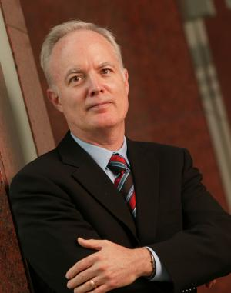 | - Lab: Kravis Leadership Institute (https://kravisleadershipinstitute.org)  - Research Interests: Leadership Development, Executive Leadership, Board Governance, Leading Organizational Change, Talent Management, High Potential Talent, Persuasion, Communications, Narratives  - Classes Taught: Leading Entrepreneurial Ventures (PSYC 141)
Gabe Cook  (gcook@cmc.edu)  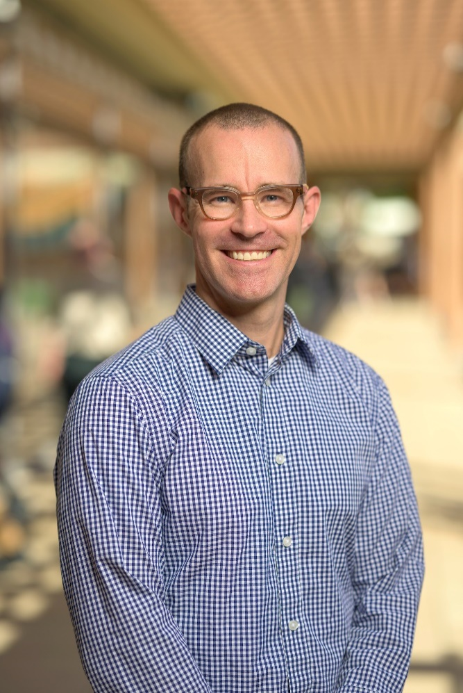 | - Lab: Data Visualization and Cognition Lab  - Research Interests:  - Data visualization: Understanding the role of attention and memory for data visualization interpretation and decision making;  - Metacognition: Awareness of learning and memory;  - Prospective memory: Mechanisms of prospective memory and everyday intentions  - Classes Taught: Cognitive Psychology (PSYC 40), Data Visualization (167), Data Science Using R
Mark Costanzo  (mcostanzo@cmc.edu)  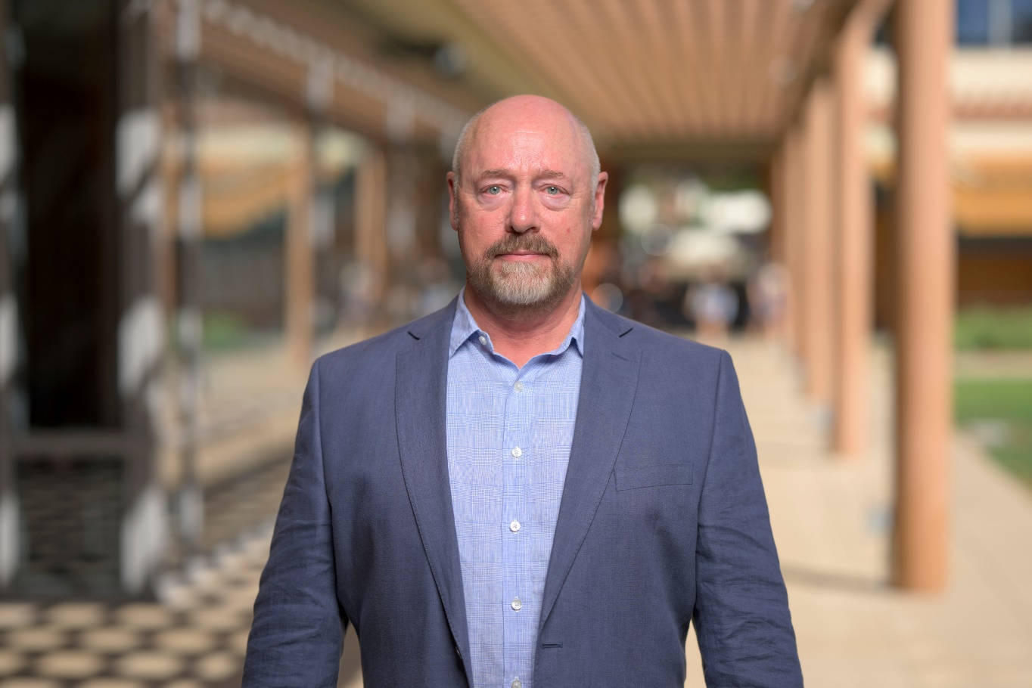 | - Lab: Center for Applied Psychological Research  - Research: Psychology and Law  - Police Interrogations and False Confessions;  - The Death Penalty;  - Negotiation, Mediation, and Dispute Resolution; Influence, Persuasion, and Coercion;  - Nonverbal Behavior and Interpersonal Perception;  - Teaching Techniques and Active Learning  - Classes Taught: Social Psychology (PSYC 92), Research Methods (PSYC 110/111L), Psychology and Law (PSYC 188)
David Day  (dday@cmc.edu)   | - Lab: Kravis Leadership Institute (https://kravisleadershipinstitute.org)  - Research Interests: Leadership  - Leader development  - Talent management and development  - Classes Taught: Organizational Psychology (PSYC 37); Leadership (PSYC 140), Becoming a Leader (PSYC 142)
Wendy de los Reyes  (Incoming Fall 2025)   | - Lab: AMPLIFY Lab (https://wendydlr.com – full lab website coming soon)  - Research Interests: Community and Developmental Psychology  - Youth civic and political engagement  - Youth mentoring  - Latinx/e families  - Immigrant and refugee adjustment  - Community-engaged research  - Youth participatory action research  - Classes Teaching: Community Psychology (PSYC 51), Youth Civic Leadership (PSYC 141), Research Methods and Practicum (PSYC 110/111L)
Stacey Doan  (sdoan@cmc.edu)   | - Lab: Applied Mind and Health Lab  - Director: Berger Institute (https://www.bergerinstitute.org/)  - Research: Biological, social and individual correlates of physical health and psychological well-being  - Emotions  - Stress  - Health  - Emotion-cognition interactions  - Parenting  - Culture  - Courses taught: Introduction to Psychology (PSYC 30), Developmental Psychology (PSYC 81), Heath Psychology (PSYC 185), Psychosocial Determinants of Health (PSYC 159)
Jennifer Feitosa  (jfeitosa@cmc.edu)  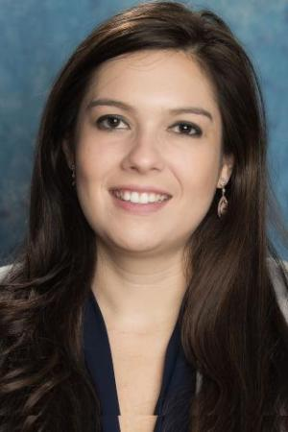 | Lab: Metrics Lab (https://feitosametricslab.wixsite.com/claremont)  - Research: Industrial Organizational Psychology  - Diversity  - Teamwork  - Measurement  - Organizational Psychology  - Classes taught: Organizational Psychology (PSYC 37), Statistics for Psychology (109), Organizational Communication and Leadership (PSYC 177)
Rachael Fenning  (rfenning@cmc.edu)  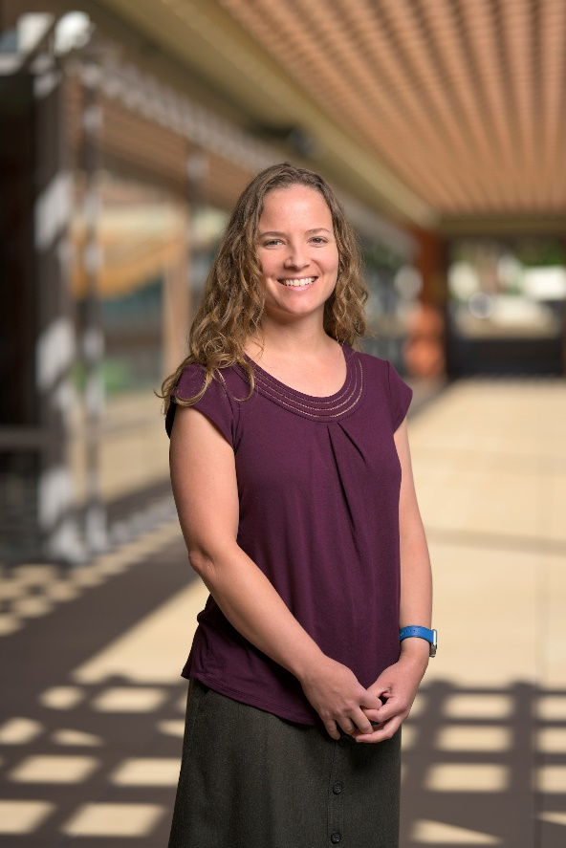 | - Lab: Claremont Autism Center  - Research Interests: Autism spectrum disorder; intellectual disabilities  - Risk and resilience processes  - Emotion regulation  - Behavior problems  - Parent-child interaction  - Intervention development and outcomes  - Classes Taught: Behavioral Psychology (PSYC 65), Clinical Research and Assessment (PSYC 119), Seminar in Behavior Modification (PSYC 120)
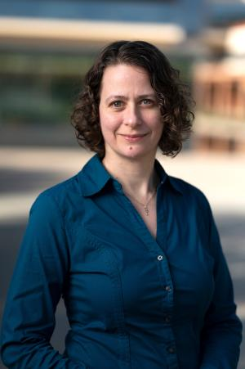  Alison Harris (aharris@cmc.edu) | - Lab: Decision Neuroscience Laboratory (https://www1.cmc.edu/pages/faculty/aharris/)  - Research Interests: Cognitive neuroscience, EEG/ERP  - Decision making: Neuroeconomics, behavioral economics  - Visual perception: Basic visual function, face and body perception, neural adaptation  - Description: In the Decision Neuroscience Laboratory, we explore how neural activity in the brain gives rise to perception and behavior. Using electroencephalography (EEG), we capture dynamic shifts in brain activity over time to understand how the brain processes visual information and makes choices.  - Classes Taught: Introduction to Psychology (PSYC 30), Sensation and Perception (PSYC 97), Neuroeconomics (ECON/PSYC 107)
Wei-Chin Hwang  (whwang@cmc.edu)  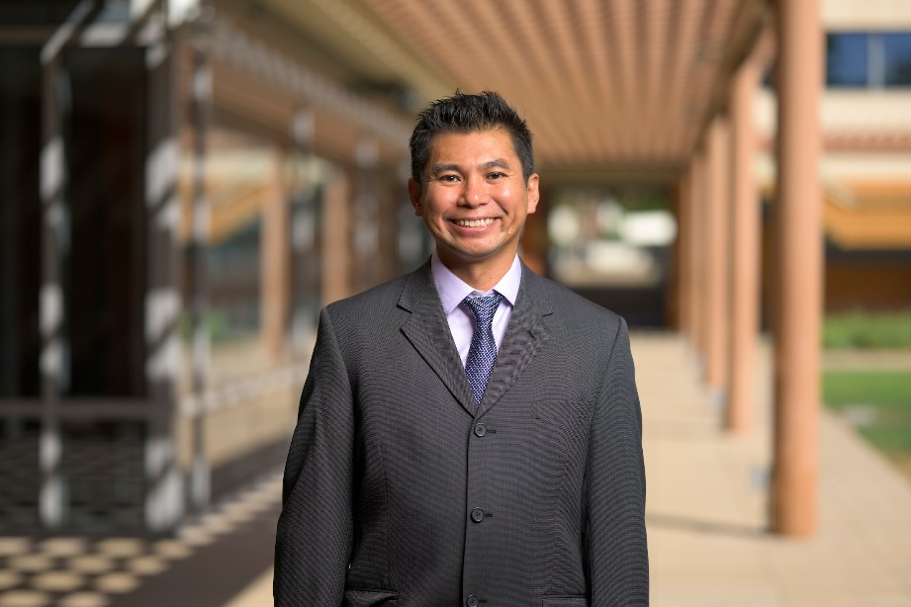 | - Lab: Cultural Influences on Mental Health Center  - Research Interests: Ethnic, racial and cultural issues in mental health and depression; psychotherapy process and treatment outcomes; cultural competency and adaptation of services for ethnic minorities  - Understanding and reducing mental health disparities, acculturation and family mental health,  - Improving psychotherapy process and outcomes, cultivating therapist cultural competency and effectiveness when working with people from different backgrounds  - Developing models and frameworks for culturally adapting treatments for ethnic minorities.  - Research psychedelics and mental health.  - Classes Taught: Introduction to Psychology; Psychological Disorders (PSYC 70); Ethnic Minority Psychology and Mental Health (PSYC 154); Mindfulness, Meditation, & Well-being (PSYC 155); Psychedelics and Mental Health
Tomoe Kanaya  (tkanaya@cmc.edu)  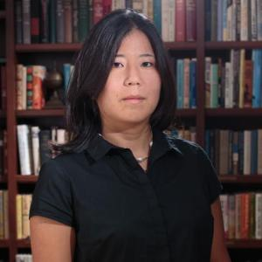 | - Lab: Child Development and Public Policy Lab  - Research Interests: Children’s memory and suggestibility development, Educational and legal policy-oriented research, Longitudinal methodology, IQ testing in special education diagnoses  - The role of language development in memory formation in bilingual and monolingual children  - The longitudinal impact of IQ scores on school children’s special education diagnoses.  - Classes Taught: Introduction to Psychology (PSYC 30), Children and Educational Policy (PSYC 126), Child Development in Diverse Contexts (PSYC 129)
Dan Krauss  (dakrauss@cmc.edu)  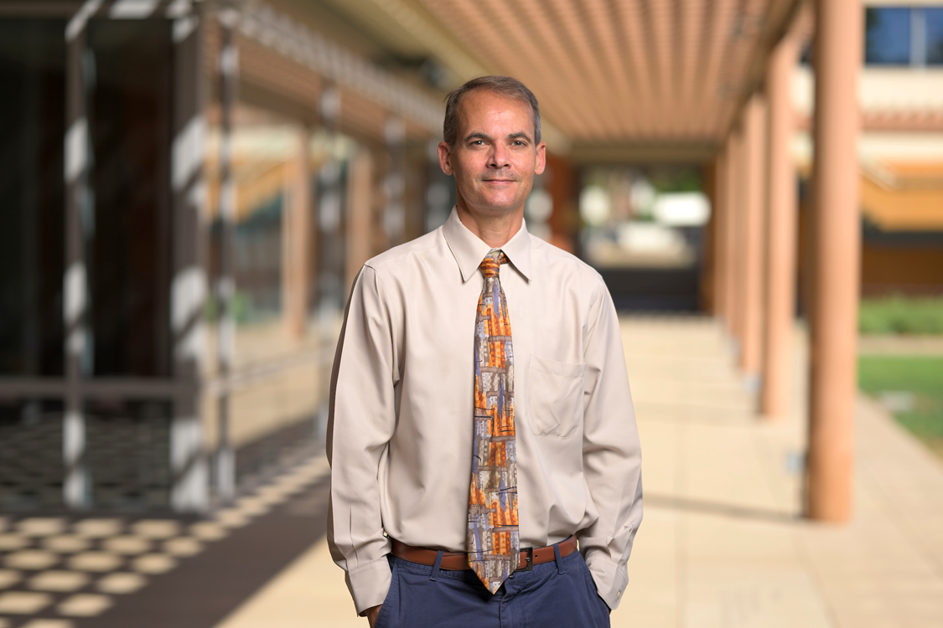 | - Lab: Psychology, Law & Policy Lab (https://psychologylawpolicylab.com/)  - Research Interests: Clinical psychology, forensic psychology, jury decision making  - Legal system: Disconnects between psychological research and practice, and how legal system utilizes this information.  - Legal decision making: How jurors and other legal actors misinterpret or misuse psychological evidence and expert testimony in decision-making.  - Classes Taught: Introduction to Psychology (PSYC 30), Psychological Disorders (PSYC 70); Forensic Psychology (PSYC 180); Seminar in Clinical Psychology with practicum, (PSYC 189)
Shana Levin  (slevin@cmc.edu)  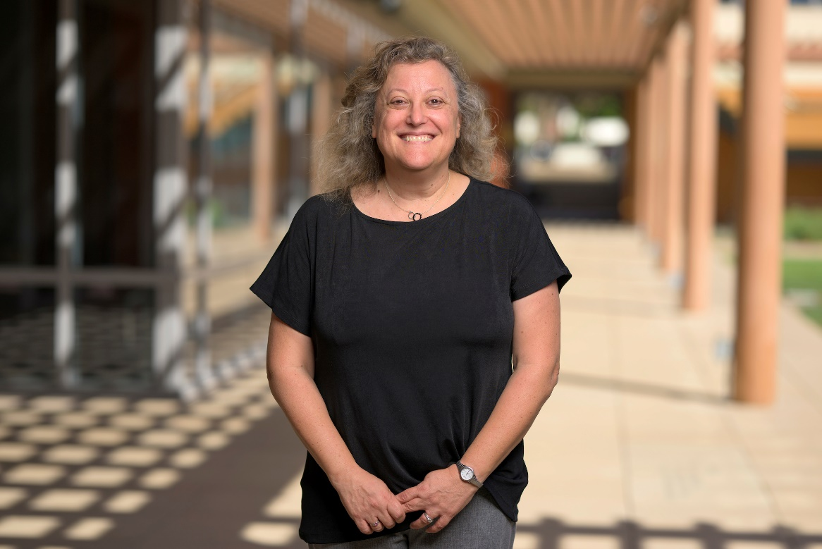 | - Research Interests: Prejudice and Intergroup Relations, Cross-cultural Intergroup Conflict  - Classes Taught: Social Psychology (PSYC 92), Statistics for Psychological Science (Psych 109), Psychology Senior Research Seminar (PSYC 198), Prejudice and Intergroup Relations (PSYC 118)  - Advising: Come see me if you are interested in learning more about a two-semester empirical senior thesis in psychological science – I will tell you about the benefits, criteria, timeline, and Psychology Senior Research Seminar that you would take with me in the fall of your senior year!
Cathy Reed  (clreed@cmc.edu)  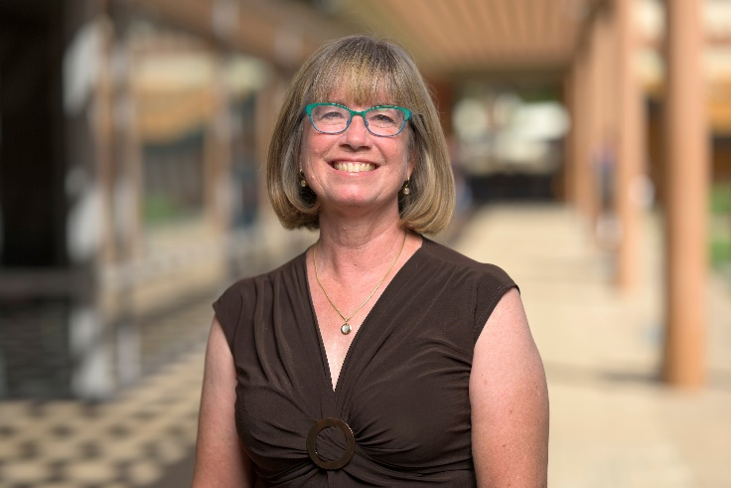 | - Lab: Cognitive Neuroscience Laboratory (https://www1.cmc.edu/pages/faculty/clreed/)  - Research Interests: Cognitive neuroscience, EEG/ERP  - Embodied perception and cognition: The influence of the body in perception, action, emotion and cognition in typical, aging and patient populations  - Multimodal perception: Integration of vision, touch, and proprioception for face and body perception  - Individual differences in brain function  - Description: We use behavioral and electrophysiological (EEG/ERP) techniques to investigate how the brain integrates information from vision, touch, and the body in real time.  - Classes Taught: Introduction to Psychology (PSYC 30), Neuropsychology (PSYC 96), Cognitive Electrophysiology: The Electric Mind (PSYC 136); Debates in Cognitive Neuroscience (PSYC 135)
Ron Riggio  (rriggio@cmc.edu)  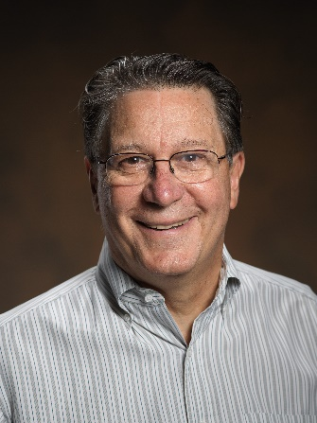 | - Lab: Kravis Leadership Institute (https://www.kravisleadershipinstitute.org/)  - Head: Leadership sequence  - Research Interests: Leadership, Organizational Psychology, Innovation, Non-verbal Psychology, Human Resources Management  - Industrial/Organizational Psychology  - Leadership: Followership  - Nonverbal Communication: Individual differences in nonverbal communication skill  - Personality and Social Psychology: Social skills  - Classes Taught: Organizational Psychology (PSYC 37), Leadership (PSYC 140); Foundations of Leadership (LEAD 10), Silicon Valley leadership course (LEAD 150)
Sharda Umanath  (sumanath@cmc.edu)   | - Lab: Memory and Aging Lab (https://www.umanathlab.com/)  - Research Interests: Human Learning, and Memory, Aging, Knowledge, Autobiographical Memory, Collective Memory  - Nature of knowledge and its influence on remembering, with particular interests in healthy aging, event memory, collective memory, and misinformation.  - How fluctuating accessibility of prior knowledge affects a person’s ability to utilize their knowledge across the lifespan.  - Classes Taught: Cognitive Psychology (PSYC 40), Autobiographical Memory (PSYC 164), Research Methods and Practicum (PSYCH 110/111L); Effective Learning Across the Lifespan (PSYC 160)
Steven Zhou  (Incoming Fall 2025)  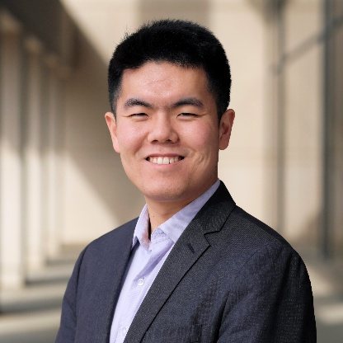 | - Lab: Stats Lab (www.stevenzhou.us – full lab website coming soon)  - Research Interests: Psychometrics, multivariate statistics, machine learning and natural language processing, leadership, careers and vocation, personality, and science communication  - How can we use advanced quantitative methods to measure, explain, and predict phenomena such as leadership, career development, and personality?  - How can we communicate scientific findings and advanced analyses to applied public audiences?  - Classes Teaching: Statistics for Psychological Science (PSYC 109), Organizational Psychology (PSYC 37), Psychometrics and Multivariate Statistics (new class)  I am excited to join the CMC faculty and am hoping to recruit student researchers for the lab! Training will be provided; you do not need to be an expert in statistics to join the lab, you just need to be interested in it!
Heidi Blocker  (hblocker@cmc.edu)  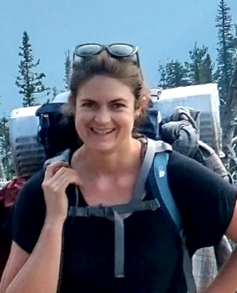 | - Visiting Professor  - Research Interests: Media representations influences on prejudice & stereotyping; Components leading to intergroup bias (minimal groups); Empathy  - Classes Taught: Introduction to Psychology (PSYC 30), Social Psychology (PSYC 92)
Emily Kan  (Emily.Kan@cmc.edu)   | - Visiting Professor  - Research Interests: Juvenile delinquency and substance use  - Classes Taught: Introduction to Psychology (PSYC 30), Developmental Psychology (PSYC 81), Research Methods (PSYC 110), Statistics for Psychological Science (Psych 109)
Sherylle Tan  (stan@cmc.edu)  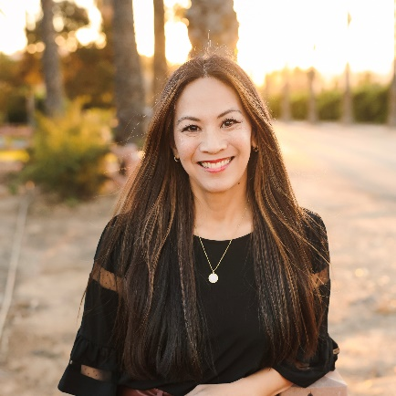 | - Visiting Professor, Interim Director of the Kravis Leadership Institute, Director of Internship and KLI Research  - Research Interests: Women and Leadership, gender and leadership, leadership development, work and family  - Classes Taught: Foundations of Leadership (Lead 10), Women and Leadership (PSY 143), Developmental Psychology (PSY 81)

